**Noise Meter**

Installation & Operation Instruction

The software is available for Windows XP, Win7, Win8 and Win10.

Contents

I. Software Installation 2

II. Operating Instruction 6

III. Common Errors and How to Solve 18

# Software Installation

The meter is applied with installing version and free-installing version. Open the folder “VoiceLAB”, and double click VoiceLAB.exe to run the software directly. Open the folder “Setup” and double click Setup.exe to install the software. Follow the steps as below:

1. Choose installing Language, there are 简体中文，繁体中文 and English for option.

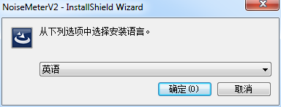

1. Click “next” for next movement.

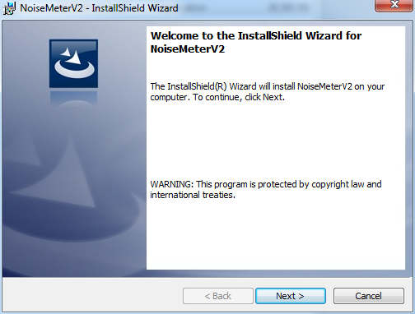

1. Select “I accept the terms in the license agreement”

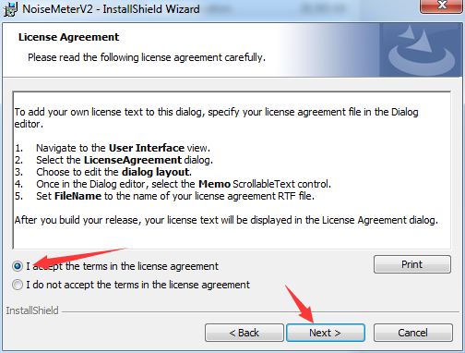

1. Click next

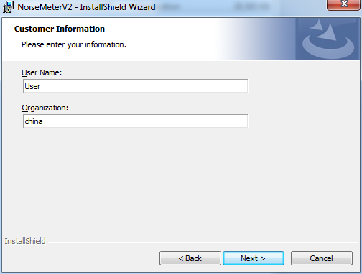

1. Take Custom installation as sample.

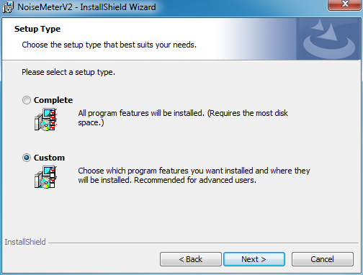

1. Set installing path. The default is disk C, click “Change” to revise the path.

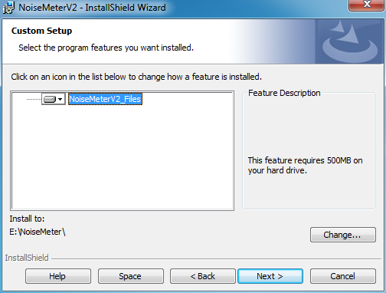

1. Click “Install”

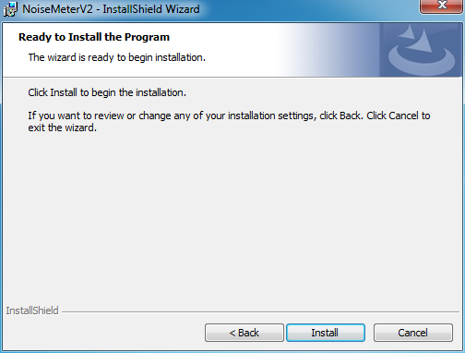

1. Click “Finish”

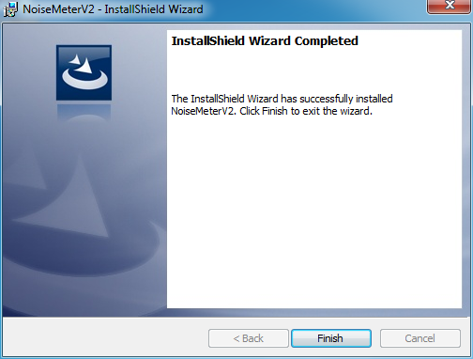

# Operating Instruction

1. **Interface**

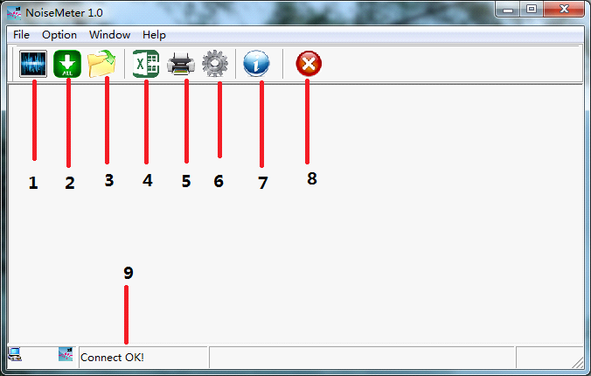

1-Samping

2-Record uploading

3-Open the file

4-Export to Excel

5-Printing

6-System setting

7-About us

8-Exit

9-USB connecting

1. **Connection to PC**

Connect the meter to PC with USB cable. “Connect OK!” means OK; “Disconnect!” means failed.

Please recheck as below steps when the device fails to connect with the computer.

1) USB cable is in good condition;

2) Computer insert is in good condition;

3) The USB insert of meter is in good condition.

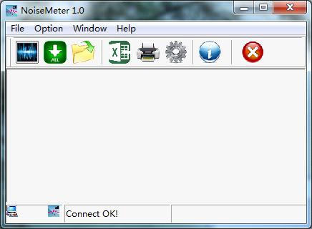

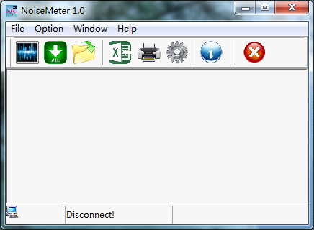

1. **Real-time Measuring**

Click  to real-time Measuring. Click  to start. Data will be updated every 1s.

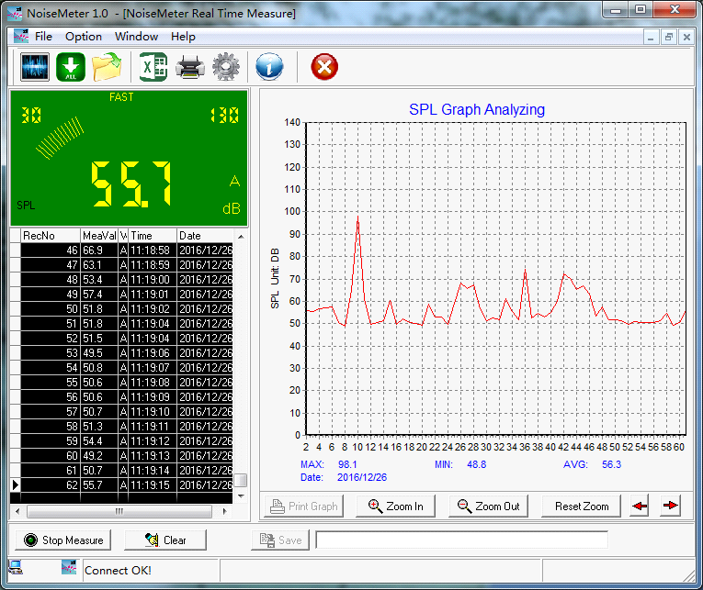

Click  to stop measuring, then click  to save data. All records will be saved as .lab file.

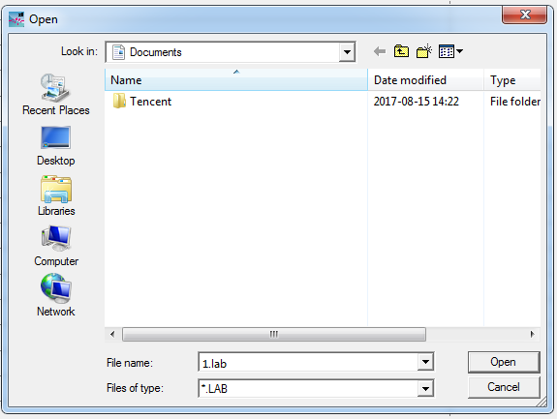

1. **Record uploading**

Click  to records interface. Choose the month which you want to import and click to upload the records.

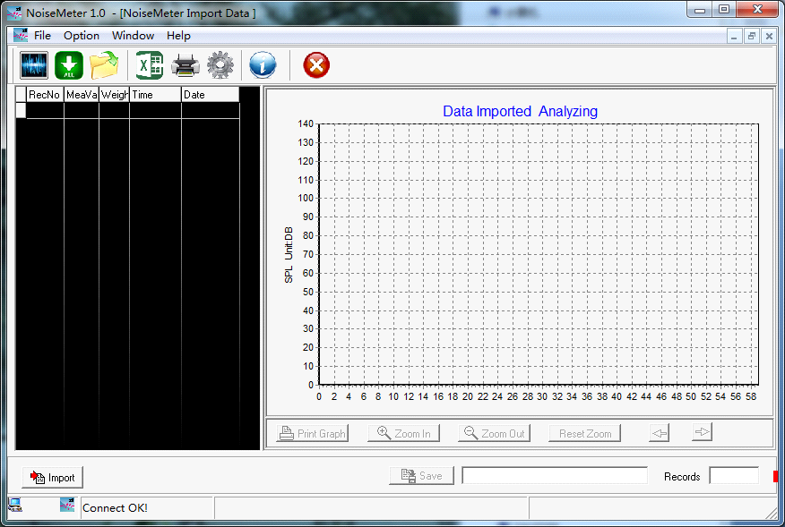

Choose the date and click Import.

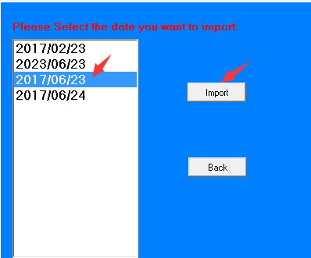

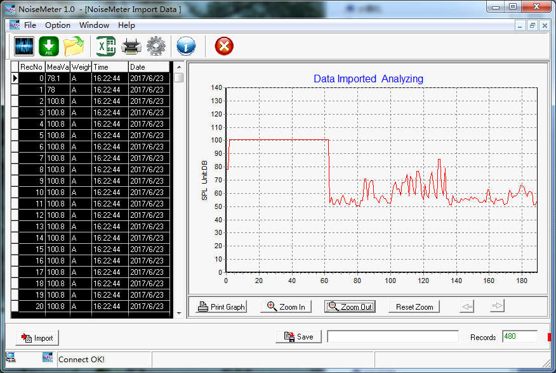

Click  to save the record in .lab files.

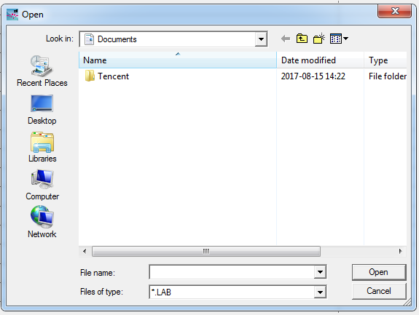

1. **Open the file**

Click , find the previous records in .lab file and open it.



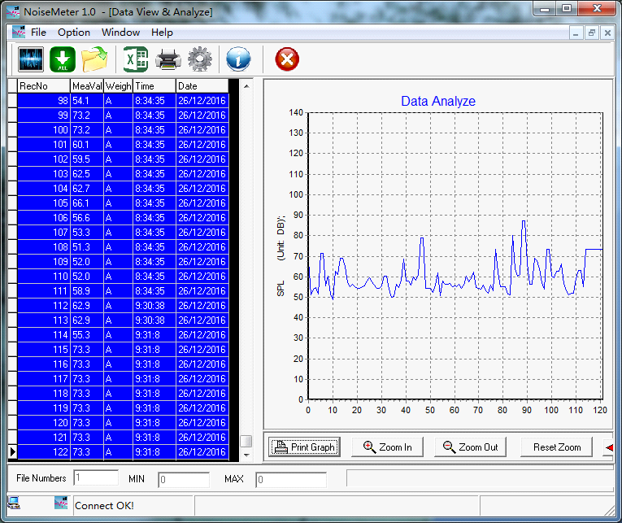

1. **Export to Excel**

Click  to export the data to Excel.

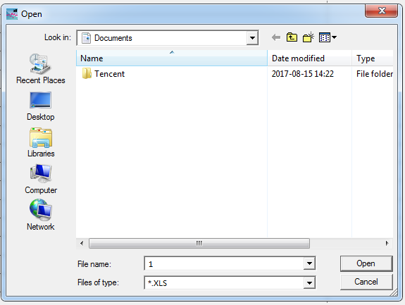

There will be Record No., Sound Value, Weight and time in the exported excel.

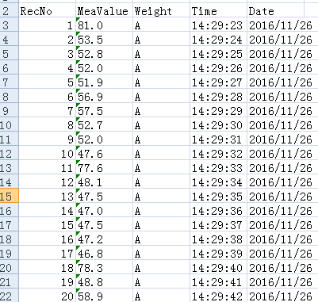

1. **Printing**

Click , Print data.

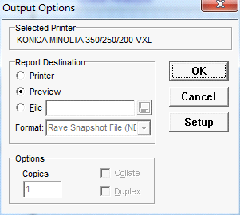

Click OK to preview.

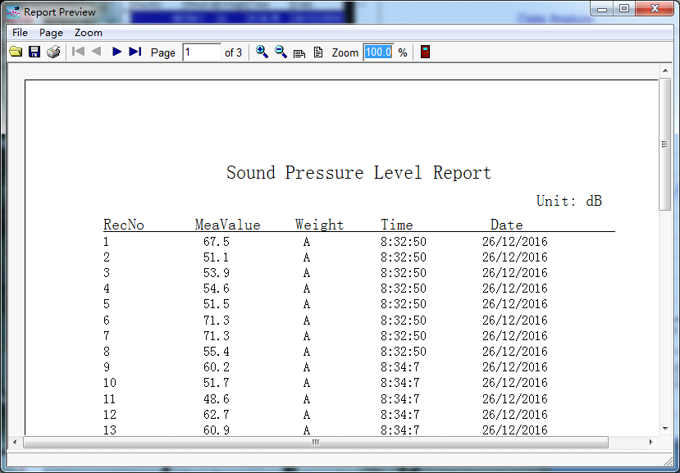

Click 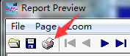, show as below:

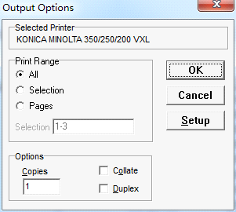

Click OK to start printing.

1. **Setting**

Click to settings.

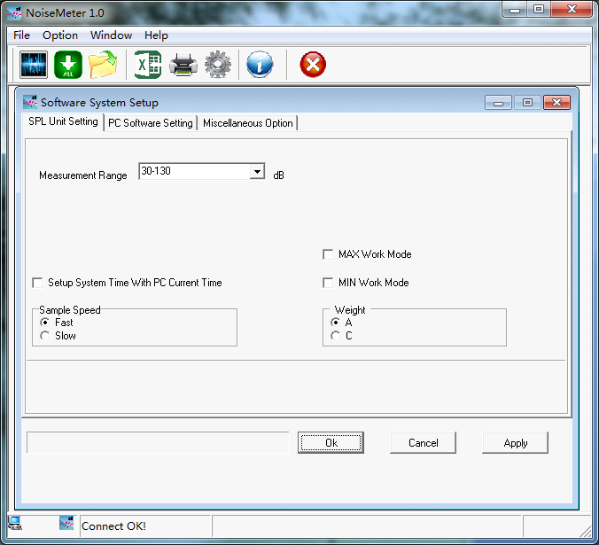

1. Set the device, Click “SPL Unit Setting” to the interface
2. Set the measuring range, select the measuring range in “Measurement Range”. Note: range selection now is not available for this model.

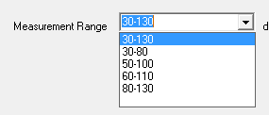

1. 
2. 
3. 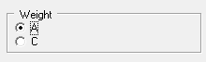
4. 
5. 
6. Set the software: Click PC Software Setting to set the software.
7. 
8. 
9. 
10. Click Miscellaneous Option to other setting.
11. Set the Company Name.



1. Finish and apply the settings.

Click after the setting, and then clickto finish.

1. **About**

Click to “About” page

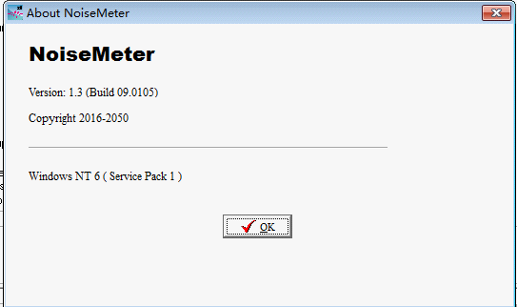

1. **Exit**

Click and choose Yes to exit the software.

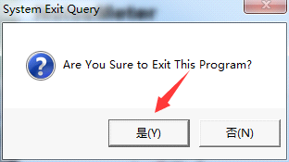

# Common Errors and How to Solve

1. Error: “the field is too small to accept the amount of data you attempted to add. Try inserting or pasting less data“

Solution: Click <the Clock, language, and Region> option in the Control Panel, and refer to the image below for Settings:

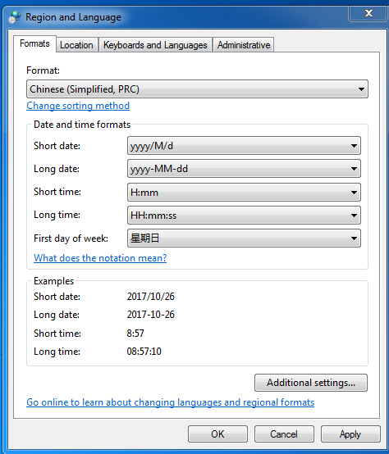

2. Error: “Access violation at address 0047DC2E in module ‘NoiseMeater.exe’. Read of address 00000030”

Solution: Run the program in a compatible Windows XP (Service Pack 3) mode. The specific operation is as below:

Right-click the program and choose Properties. Then select compatibility in pop-up Windows, check “the option of Run this program in compatibility mode for: Windows XP (Service Pack 3)” in the Compatibility.

